IBM Applied Data Science Capstone Project Report
IBM Applied Data Science Capstone Submitted by: Bhakti Shinde B.Tech Computer Science Engineering (AI) VIT Pune

SpaceX Falcon 9 First Stage Landing Prediction

- Executive Summary
This project analyzes SpaceX Falcon 9 launch data to understand the factors associated with successful first-stage landing outcomes and to build machine learning models for landing prediction.
The analysis combines data collection, data wrangling, exploratory data analysis, SQL queries, interactive visualization, geographic visualization, and predictive modeling.
Important variables analyzed include payload mass, orbit, launch site, flight number, booster information, reuse characteristics, and landing class.
Four machine learning algorithms were evaluated: Logistic Regression, Support Vector Machine, Decision Tree, and K-Nearest Neighbors. Their performance was compared using test-set accuracy.
The project demonstrates how data science and machine learning can be applied to historical launch data to study Falcon 9 landing outcomes.
.
- Introduction
SpaceX has developed reusable Falcon 9 rockets to reduce the cost of space launches. The successful recovery of the first stage is an important part of the reusable launch system.
The objective of this project is to analyze historical Falcon 9 launch data and predict whether the first stage will successfully land.
The project investigates relationships between landing success and variables such as payload mass, orbit, launch site, flight number, and booster reuse characteristics.
The final machine learning models classify launches into two classes: successful landing and unsuccessful landing.
.
- Data Collection – SpaceX API
- 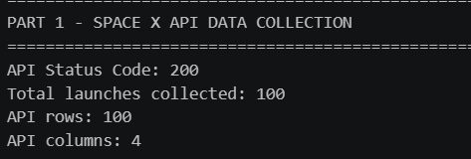
Data Collection – Web Scraping
TODO: Add scraping process/screenshots and GitHub URL.
- Data Wrangling Methodology
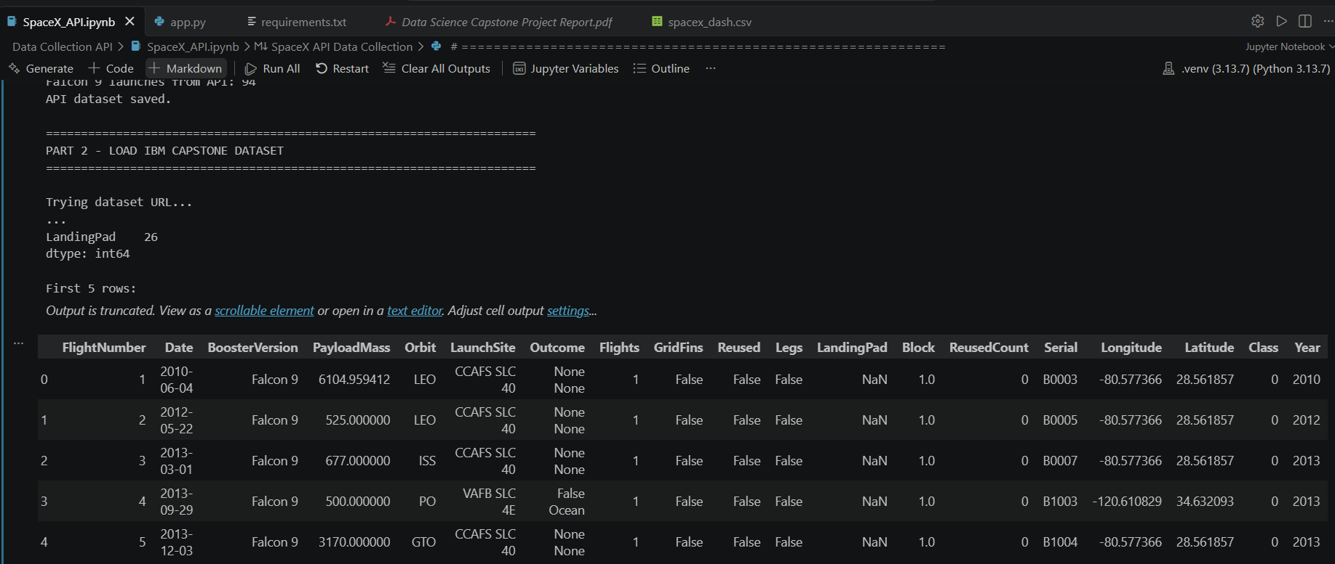
The collected data was cleaned and prepared for analysis using Pandas.
The main preprocessing steps included converting launch dates into datetime format, extracting the launch year, filtering Falcon 9 records, checking missing values, converting numerical variables to appropriate data types, and preparing categorical variables for machine learning.
Categorical variables such as orbit, launch site, and booster serial number were converted into numerical features using one-hot encoding.
- EDA with Data Visualization
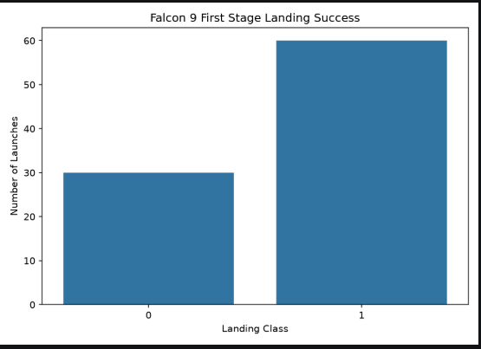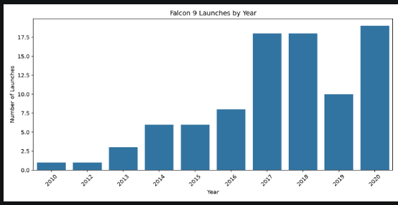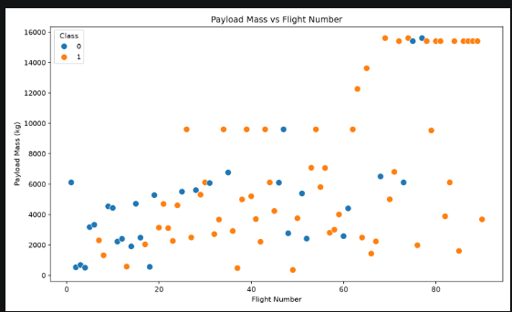
Exploratory analysis was performed to identify patterns in Falcon 9 launches and landing outcomes.
The analysis examined launch frequency by year, landing success distribution, payload mass, orbital destination, and launch site.
The visualizations provide an overview of how launch activity and landing outcomes vary across different operational conditions.
- EDA with SQL
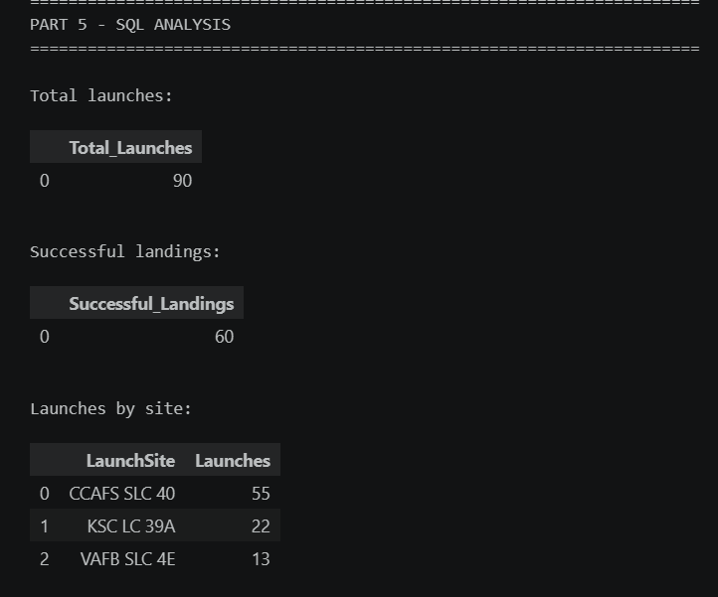
SQLite was used to perform SQL queries on the Falcon 9 dataset.

Queries included:

• Total number of launches
• Number of successful landings
• Launches by launch site
• Landing results by orbit
• Successful landings by year
• Minimum, maximum and average payload mass
- Interactive Visual Analytics – Folium

Interactive Launch Site Map
A Folium-based interactive map was created to visualize the geographic locations of Falcon 9 launch sites.
The map uses latitude and longitude information from the dataset and displays launch sites as interactive markers. Users can inspect the launch site names directly on the map.
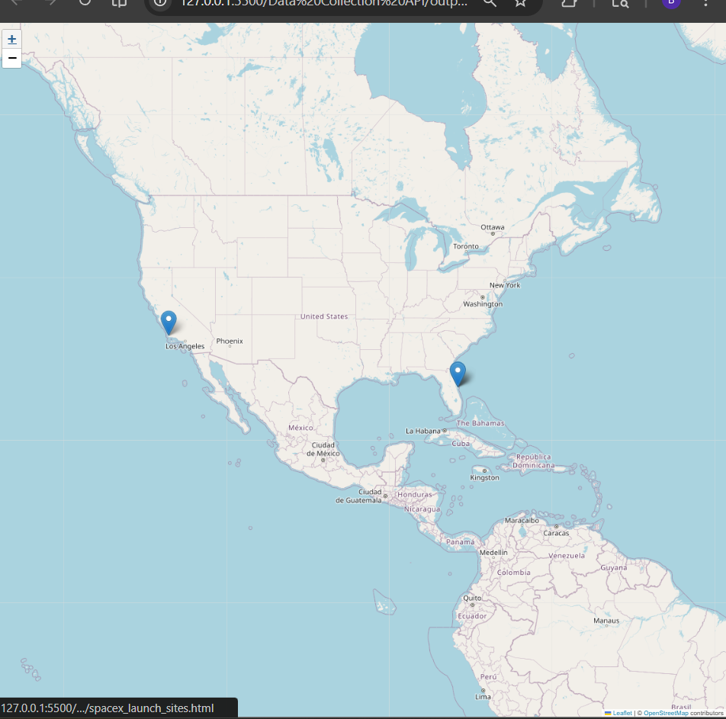

- Interactive Visual Analytics – Plotly Dash
An interactive Plotly Dash dashboard was developed to explore Falcon 9 landing outcomes.
The dashboard allows users to select a launch site and dynamically view the landing success distribution and the relationship between payload mass and flight number.
The dashboard provides an interactive interface for exploring the launch dataset.
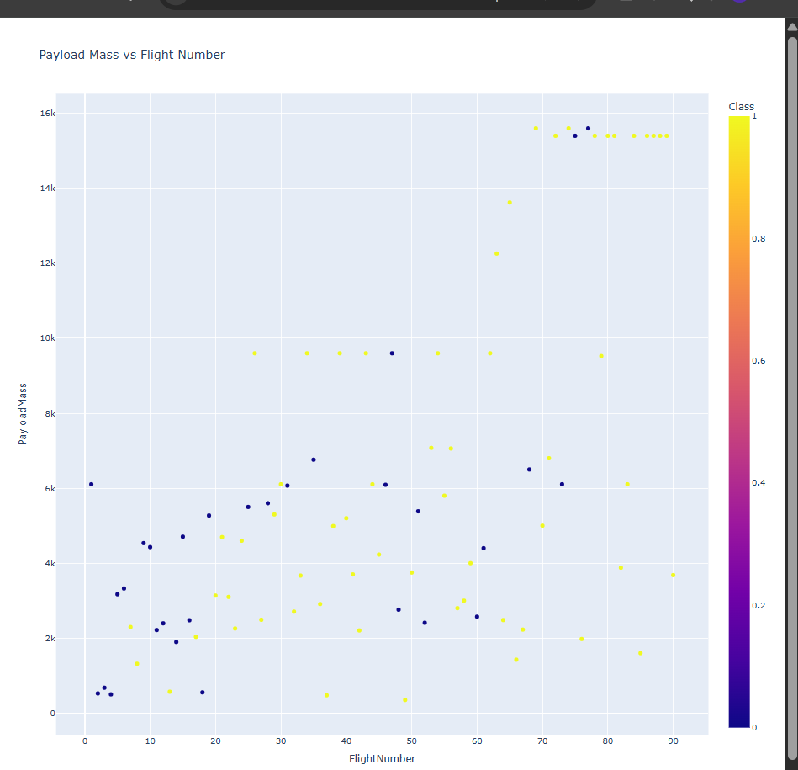
.
- Machine Learning
Target Variable:
Class

0 → Unsuccessful landing
1 → Successful landing
Models:
• Logistic Regression
• Support Vector Machine
• Decision Tree
• K-Nearest Neighbors
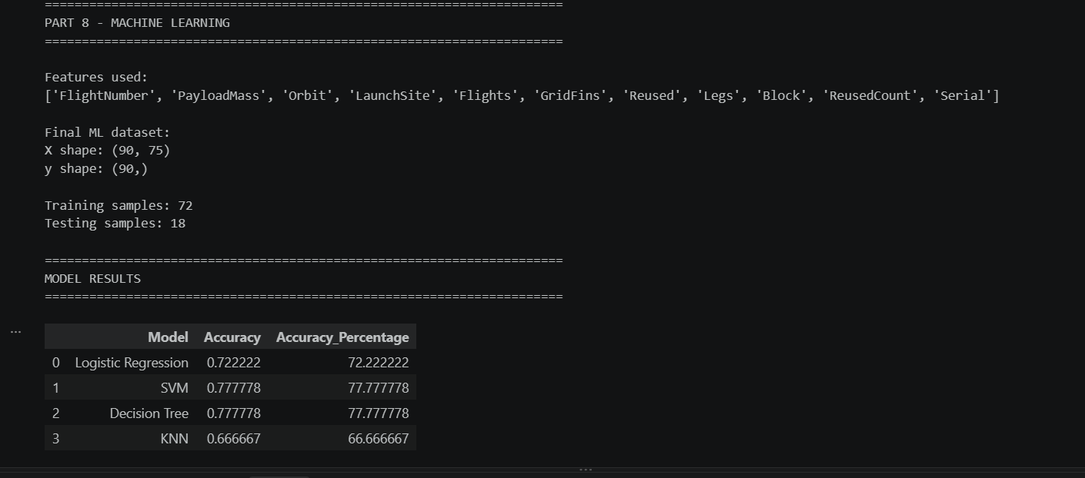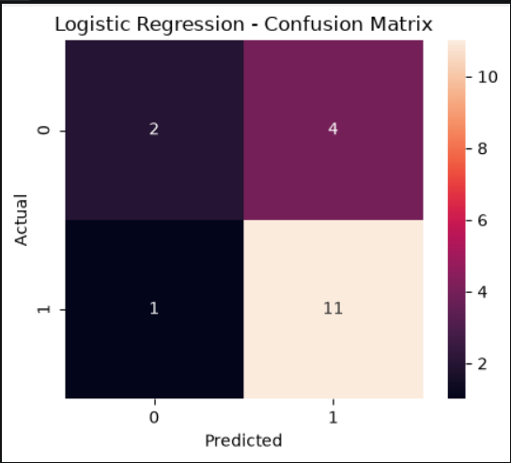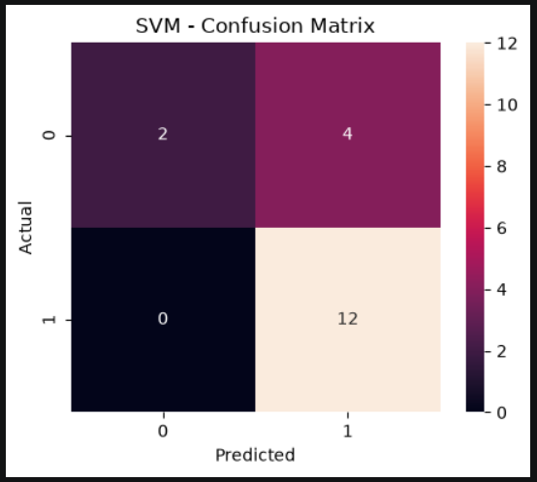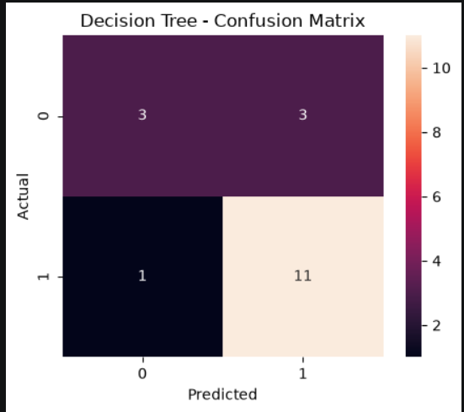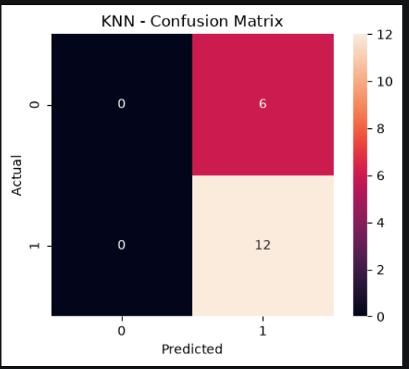
- Model Results
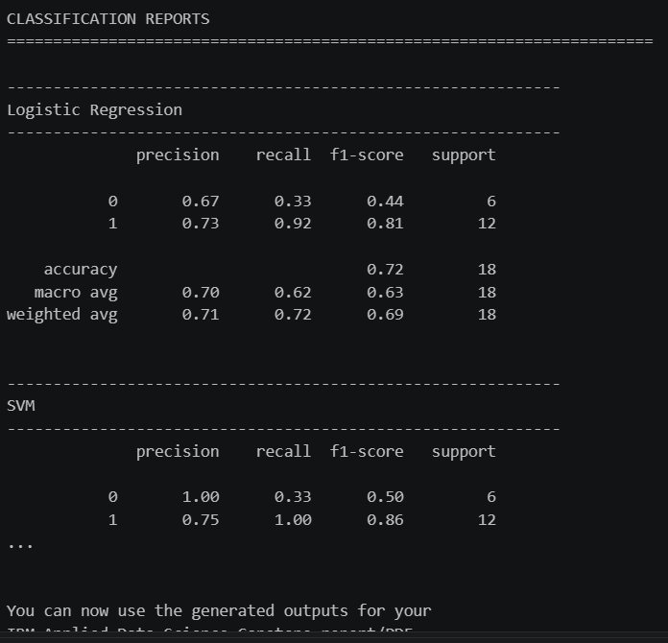
- Conclusion
This project demonstrated a complete data science workflow for analyzing Falcon 9 first-stage landing outcomes.
The workflow included API-based data collection, data wrangling, exploratory analysis, SQL analysis, geographic visualization, interactive dashboard development, and machine learning.
The analysis identified relationships between landing outcomes and operational variables such as payload, orbit, launch site, flight history, and booster characteristics.
Multiple classification algorithms were trained and evaluated on the prepared dataset. The resulting model comparison demonstrates how machine learning can be used to classify historical Falcon 9 landing outcomes.

GitHub Repository
https://github.com/bhaktishinde1710-art/SpaceX_Data_Science_Capstone_GitHub

